**356356356356356** Prin ciples of Power System

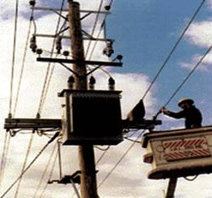

**CONTENTS**

14

C H A P TER

**A.C. Distribution**

# Introduction

* 1. **A.C. Distribution Calculations**
  2. **Methods of Solving A.C. Distribution Problems**
  3. **3-Phase Unbalanced Loads**
  4. **Four-Wire Star-Connected Unbal- anced Loads**
  5. **Ground Detectors**

I

n the beginning of electrical age, electricity was generated, transmitted and distributed as direct current. The principal disadvantage of

d.c. system was that voltage level could not readily be changed, except by the use of rotating machinery, which in most cases was too expen- sive. With the development of transformer by George Westinghouse, a.c. system has become so predominant as to make d.c. system practically extinct in most parts of the world. The present day large power system has been possible only due to the adoption of a.c. system.

Now-a-days, electrical energy is generated, transmitted and distributed in the form of alter- nating current as an economical proposition. The electrical energy produced at the power station is transmitted at very high voltages by 3-phase, 3- wire system to step-down sub-stations for distri- bution. The distribution system consists of two parts *viz*. primary distribution and secondary dis- tribution. The primary distribution circuit is 3- phase, 3-wire and operates at voltages (3·3 or 6·6 or 11kV) somewhat higher than general utilisation levels. It delivers power to the secondary distri- bution circuit through distribution transformers

**356**



**CONTENTS**

situated near consumers’ localities. Each distribution transformer steps down the voltage to 400 V and power is distributed to ultimate consumers’ by 400/230 V, 3-phase, 4-wire system. In this chap- ter, we shall focus our attention on the various aspects of a.c. distribution.

# A.C. Distribution C alculations

A.C. distribution calculations differ from those of d.c. distribution in the following respects :

* 1. In case of d.c. system, the voltage drop is due to resistance alone. However, in a.c. system, the voltage drops are due to the combined effects of resistance, inductance and capacitance.
  2. In a d.c. system, additions and subtractions of currents or voltages are done arithmetically but in case of a.c. system, these operations are done vectorially.
  3. In an a.c. system, power factor (p.f.) has to be taken into account. Loads tapped off form the distributor are generally at different power factors. There are two ways of referring power factor *viz*

1. It may be referred to supply or receiving end voltage which is regarded as the reference vector.
2. It may be referred to the voltage at the load point itself.

There are several ways of solving a.c. distribution problems. However, symbolic notation method has been found to be most convenient for this purpose. In this method, voltages, currents and imped- ances are expressed in complex notation and the calculations are made exactly as in d.c. distribution.

# Metho ds of Solving A.C. Distribution Pr o blems

In a.c. distribution calculations, power factors of various load currents have to be considered since currents in different sections of the distributor will be the vector sum of load currents and not the arithmetic sum. The power factors of load currents may be given (*i*) *w.r.t*. receiving or sending end voltage or (*ii*) *w.r.t*. to load voltage itself. Each case shall be discussed separately.

* + 1. **Power factors referred to receiving end voltage.** Consider an a.c. distributor *AB* with con- centrated loads of *I*1 and *I*2 tapped off at points *C* and *B* as shown in Fig. 14.1. Taking the receiving end voltage *VB* as the reference vector, let lagging power factors at *C* and *B* be cos 1 and cos 2 *w.r.t. VB*. Let *R*1, *X* 1 and *R*2, *X* 2 be the resistance and reactance of sections *AC* and *CB* of the distributor.

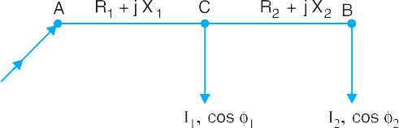

Impedance of section *A C*, *ZAC* = *R*1 + *j X*1

Impedance of section *CB*, *ZCB* = *R*2 + *j X*2

Load current at point *C*, *I*1 = *I*1 (cos 1  *j* sin 1) Load current at point *B*, *I*2 = *I*2 (cos 2  *j* sin 2) Current in section *CB*, *ICB* = *I*2 = *I*2 (cos 2  *j* sin 2)

Current in section *A C*, *IAC* = *I*1  *I*2

= *I*1 (cos 1  *j* sin 1) + *I*2 (cos 2  *j* sin 2) Voltage drop in section *CB*, *VCB* = *ICB ZCB* = *I*2 (cos 2  *j* sin 2) (*R*2 + *j X* 2)

.

. 

_. 

.

Voltage drop in section *A C*, *VAC* =



*IAC ZAC*

*I*1

*I*2  *ZAC*

**358** Prin ciples of Power System

= [*I*1(cos 1  *j* sin 1) + *I*2 (cos 2  *j* sin 2)] [*R*1 + *j X*1]

Sending end voltage, *VA* = *VB*  *VCB*

Sending end current, *I**A* = *I*1  *I*2

* *VAC*



The vector diagram of the a.c. distributor under these conditions is shown in Fig. 14.2. Here, the receiving end voltage *VB* is taken as the reference vector. As power factors of loads are given *w.r.t. VB*, therefore, *I*1 and *I*2 lag behind *VB* by 1 and 2 respectively.

* + 1. **Power factors referred to respective load voltages.** Suppose the power factors of loads in the previous Fig. 14.1 are referred to their respective load voltages. Then 1 is the phase angle between *VC* and *I*1 and 2 is the phase angle between *VB* and *I*2. The vector diagram under these conditions is shown in Fig. 14.3.

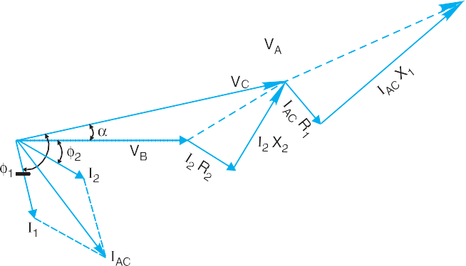

Voltage drop in section *CB* = *I*2 *ZCB* = *I*2 (cos 2  *j* sin 2) (*R*2 + *j X*2) Voltage at point *C* = *VB* + Drop in section *CB* = *VC*   (say)

Now *I*1 = *I*1   1 *w.r.t*. voltage *VC*

 *I*1 = *I*1   (1  ) *w.r.t*. voltage *VB*

*i.e. I*1 = *I*1 [cos (1  )  *j* sin (1  )]

Now *IAC* = *I*1  *I*2

A.C. Distribution **359**



= *I*1 [cos (1  )  *j* sin (1  )] + *I*2 (cos 2  *j* sin 2) Voltage drop in section *AC* = *IAC ZAC*

 Voltage at point *A* = *VB* + Drop in *CB* + Drop in *AC*

**Example 14.1.** *A single phase a.c. distributor AB 300 metres long is fed from end A and is*

*loaded as under :*

1. *100 A at 0·707 p.f. lagging 200 m from point A*
2. *200 A at 0·8 p.f. lagging 300 m from point A*

*The load resistance and reactance of the distributor is 0·2*  *and 0·1*  *per kilometre. Calculate the total voltage drop in the distributor. The load power factors refer to the voltage at the far end.*

**Solution.** Fig. 14.4 shows the single line diagram of the distributor. Impedance of distributor/km = (0·2 + *j* 0·1) 

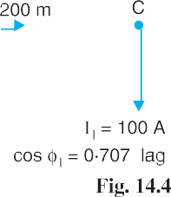

Impedance of section *AC*, *ZAC* = (0·2 + *j* 0·1)  200/1000 = (0·04 + *j* 0·02)  Impedance of section *CB*, *ZCB* = (0·2 + *j* 0·1)  100/1000 = (0·02 + *j* 0·01)  Taking voltage at the far end *B* as the reference vector, we have,

Load current at point *B*, *I*2 = *I*2 (cos 2  *j* sin 2) = 200 (0·8  *j* 0·6)

= (160  *j* 120) A

Load current at point *C*, *I*1 = *I*1 (cos 1  *j* sin 1) = 100 (0·707  *j* 0·707)

= (70·7 *j* 70·7) A

Current in section *CB*, *ICB* = *I*2 = (160  *j* 120) A

Current in section *AC*, *IAC* = *I*1  *I*2 = (70·7  *j* 70·7) + (160  *j* 120)

= (230·7  *j* 190·7) A

Voltage drop in section *CB*, *VCB* = *ICB ZCB* = (160  *j* 120) (0·02 + *j* 0·01)

= (4·4  *j* 0·8) volts

Voltage drop in section *AC*, *VAC* = *IAC ZAC* = (230·7  *j* 190·7) (0·04 + *j* 0·02)

= (13·04  *j* 3·01) volts

Voltage drop in the distributor = *VAC*  *VCB*

= (13·04  *j* 3·01) + (4·4  *j* 0·8)

= (17·44  *j* 3·81) volts

a17  44f2  a3 81f2

Magnitude of drop =

= **17·85 V**

**Example 14.2.** *A single phase distributor 2 kilometres long supplies a load of 120 A at 0·8 p.f.*

*lagging at its far end and a load of 80 A at 0·9 p.f. lagging at its mid-point. Both power factors are*

**360** Prin ciples of Power System



*referred to the voltage at the far end. The resistance and reactance per km* (*go and return*) *are 0·05*  *and 0·1*  *respectively. If the voltage at the far end is maintained at 230 V, calculate :*

1. *voltage at the sending end*
2. *phase angle between voltages at the two ends.*

**Solution.** Fig. 14.5 shows the distributor *AB* with *C* as the mid-point Impedance of distributor/km = (0·05 + *j* 0·1) 

Impedance of section *AC*, *Z AC* = (0·05 + *j* 0·1)  1000/1000 = (0·05 + *j* 0·1) 

Impedance of section *CB*, *ZCB* = (0·05 + *j* 0·1)  1000/1000 = (0·05 + *j* 0·1) 

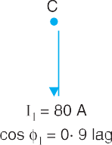

Let the voltage *VB* at point *B* be taken as the reference vector.

Then, *VB* = 230 + *j* 0

1. Load current at point *B*, *I*2 = 120 (0·8  *j* 0·6) = 96  *j* 72 Load current at point *C*, *I*1 = 80 (0·9  *j* 0·436) = 72  *j* 34·88

Current in section *CB*, *ICB* = *I*2 = 96  *j* 72

Current in section *AC*, *IAC* = *I*1  *I*2 = (72  *j* 34·88) + (96  *j* 72)

= 168  *j* 106·88

Drop in section *CB*, *VCB* = *ICB ZCB* = (96  *j* 72) (0·05 + *j* 0·1)

= 12 + *j* 6

Drop in section *AC*, *VAC* = *IAC ZAC* = (168  *j* 106·88) (0·05 + *j* 0·1)

= 19·08 + *j* 11·45

 Sending end voltage, *VA* = *VB*  *VCB*  *VAC*

= (230 + *j* 0) + (12 + *j* 6) + (19.08 + *j* 11.45)

= 261.08 + *j* 17.45

Its magnitude is =

a261 08f2  a17  45f2

1. The phase difference  between *VA* and *VB* is given by :

tan  = 17 45 = 0·0668

⋅

261 08

  = tan1 0·0668 = **3·82o**

= **261·67 V**

**Example 14.3.** *A single phase distributor one km long has resistance and reactance per con-*

*ductor of 0·1*  *and 0·15*  *respectively. At the far end, the voltage VB = 200 V and the current is 100 A at a p.f. of 0·8 lagging. At the mid-point M of the distributor, a current of 100 A is tapped at a p.f.*

A.C. Distribution **361**



*of 0·6 lagging with reference to the voltage VM at the mid-point. Calculate :*

1. *voltage at mid-point*
2. *sending end voltage VA*
3. *phase angle between VA and VB*

**Solution.** Fig. 14.6 shows the single line diagram of the distributor *AB* with *M* as the mid-point. Total impedance of distributor = 2(0·1 + *j* 0·15) = (0·2 + *j* 0·3) 

Impedance of section *AM*, *ZAM* = (0·1 + *j* 0·15) 

Impedance of section *MB*, *ZMB* = (0·1 + *j* 0·15) 

Let the voltage *VB* at point *B* be taken as the reference vector. Then, *VB* = 200 + *j* 0

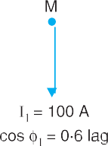

1. Load current at point *B*, *I*2 = 100 (0·8  *j* 0·6) = 80  *j* 60 Current in section *MB*, *IMB* = *I*2 = 80  *j* 60

Drop in section *MB*, *VMB* = *IMB ZMB*

= (80  *j* 60) (0·1 + *j* 0·15) = 17 + *j* 6

 Voltage at point *M*, *VM* = *VB*  *VMB* = (200 + *j* 0) + (17 + *j* 6)

= 217 + *j* 6

Its magnitude is = = **217·1 V**

a217f2  a6f2

Phase angle between *V* and *V* ,  = tan1 6/217 = tan1 0·0276 = 1·58o

*M B*

1. The load current *I*1 has a lagging p.f. of 0·6 *w.r.t*. *VM*. It lags behind *VM* by an angle

 = cos1 0·6 = 53·13o

1

 Phase angle between *I* and *V* ,  =    = 53·13o  1·58 = 51·55o

1 *B* 1 1

Load current at *M*, *I*1 = *I*1 (cos 1  *j* sin ) = 100 (cos 51·55º  *j* sin 51·55º)

= 62·2  *j* 78·3

Current in section *AM*, *IAM* = *I*1  *I*2 = (62·2  *j* 78·3) + (80  *j* 60)

= 142·2  *j* 138·3

Drop in section *AM*, *VAM*

. .

= *I AM ZAM* = (142·2  *j* 138·3) (0·1 + *j* 0·15)

= 34·96 + *j* 7·5

Sending end voltage, *VA* = *VM*  *VAM*

= (217 + *j* 6) + (34·96 + *j* 7·5)

**362** Prin ciples of Power System



= 251·96 + *j* 13·5

Its magnitude is =

a251 96f2  a13 5f2

## = 252·32 V

1. The phase difference  between *VA* and *VB* is given by :

tan  = 13·5/251·96 = 0·05358

  = tan1 0·05358 = **3·07o**

Hence supply voltage is 252·32 V and leads *VB* by 3·07º.

**Example 14.4.** *A single phase ring distributor ABC is fed at A. The loads at B and C are 20 A*

*at 0.8 p.f. lagging and 15 A at 0.6 p.f. lagging respectively ; both expressed with reference to the voltage at A. The total impedance of the three sections AB, BC and CA are* (*1 + j 1*), (*1+ j2*) *and* (*1 + j3*) *ohms respectively. Find the total current fed at A and the current in each section. Use Thevenin’s theorem to obtain the results.*

**Solution.** Fig. 14.7 (*i*) shows the ring distributor *ABC*. Thevenin’s theorem will be used to solve this problem. First, let us find the current in *BC*. For this purpose, imagine that section *BC* is removed as shown in Fig. 14.7 (*ii*).

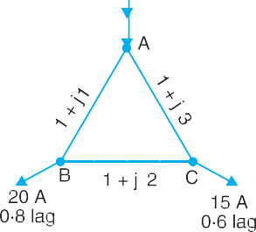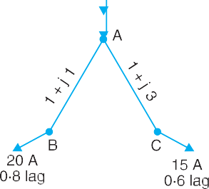

Referring to Fig.14.7 (*ii*), we have,

Current in section *AB* = 20 (0·8  *j* 0.6) = 16  *j* 12

Current in section *AC* = 15 (0·6  *j* 0·8) = 9  *j* 12 Voltage drop in section *AB* = (16  *j* 12) (1 + *j*1) = 28 + *j* 4 Voltage drop in section *AC* = (9  *j* 12) (1 + *j* 3) = 45 + *j* 15

Obviously, point *B* is at higher potential than point *C*. The p.d. between *B* and *C* is Thevenin’s equivalent circuit e.m.f. *E*0 *i.e.*

Thevenin’s equivalent circuit e.m.f., *E*0 = p.d. between *B* and *C*

= (45 + *j* 15)  (28 + *j* 4) = 17 + *j* 11

Thevenin’s equivalent impedance *Z*o can be found by looking into the network from points *B* and

*C*.

Obviously, *Z*0 = (1 + *j*1) + (1 + *j* 3) = 2 + *j*4

 Current in *BC* = *E*0

*Z*0  Impedance of *BC*

= 17  *j*11  17  *j*11

b2  *j*4g  b1  *j*2g 3  *j*6

= 2·6  *j* 1·53 = **3****30·48º A**

Current in *AB* = (16  *j* 12) + (2·6  *j* 1·53)

A.C. Distribution **363**



= 18·6  *j* 13·53 = **23****36·03o A**

Current in *AC* = (9  *j* 12)  (2·6  *j* 1·53)

= 6·4  *j* 10·47 = **12·27****58·56o A**

Current fed at *A* = (16  *j* 12) + (9  *j* 12)

= 25  *j* 24 = **34·65** **43·83o A**

**Example 14.5.** *A 3-phase, 400V distributor AB is loaded as shown in Fig.14.8. The 3-phase*

*load at point C takes 5A per phase at a p.f. of 0*·*8 lagging. At point B, a 3-phase, 400 V induction motor is connected which has an output of 10 H.P. with an efficiency of 90% and p.f. 0*·*85 lagging.*

*If voltage at point B is to be maintained at 400 V, what should be the voltage at point A ? The resistance and reactance of the line are 1* *and 0*·*5* *per phase per kilometre respectively.*

**Solution.** It is convenient to consider one phase only. Fig.14.8 shows the single line diagram of the distributor. Impedance of the distributor per phase per kilometre = (1 + *j* 0·5) .

|  |  |  |
| --- | --- | --- |
| Impedance of section *AC*, | *ZAC* | = (1 + *j* 0*·*5)  600/1000 = (0*·*6 + *j* 0*·*3)  |
| Impedance of section *CB*, | *ZCB* | = (1 + *j* 0*·*5)  400/1000 = (0*·*4 + *j* 0*·*2)  |



Phase voltage at point *B*, *VB* = 400/ 3 = 231 V

Let the voltage *VB* at point *B* be taken as the reference vector. Then, *VB* = 231 + *j* 0

Line current at *B* = H. P.  746 3  line voltage  p. f.  efficiency

= 10  746 = 14*·*08 A

3  400  0  85  0  9

 *Current/phase at *B*, *I*2 = 14*·*08 A

Load current at *B*, *I*2 = 14*·*08 (0*·*85  *j* 0*·*527) = 12  *j* 7*·*4 Load current at *C*, *I*1 = 5 (0*·*8 – *j* 0*·*6) = 4  *j* 3

.

Current in section *AC*,

Current in section *CB*,

*I AC* = *I*1  *I*2 = (4  *j* 3) + (12  *j* 7*·*4)

. = 16  *j* 10*·*4

*I CB* = *I*2 = 12  *j* 7·4

Voltage drop in *CB*, *VCB* = *ICB ZCB* = (12  *j* 7·4) (0*·*4 + *j* 0*·*2)

= 6*·*28  *j* 0*·*56

Voltage drop in *AC*, *V AC* = *I AC Z AC* = (16  *j* 10*·*4) (0*·*6 + *j* 0*·*3)

= 12*·*72  *j* 1*·*44

* In a 3-phase system, if the type of connection is not mentioned, then star connection is understood.

**364** Prin ciples of Power System



|  |  |  |
| --- | --- | --- |
| Voltage at *A* per phase, | *V A* | = *V B*  *VCB*  *V AC* |
| Magnitude of *VA*/phase |  | = (231 + *j* 0) + (6·28  *j* 0*·*56) + (12*·*72  *j* 1*·*44)  = 250  *j* 2  = a250f2  a2f2 = 250 V |
|  Line voltage at *A* |  | = 3  250 = **433 V** |
| **Example 14.6.** *A 3-phase ring main ABCD fed at A at 11 kV supplies balanced loads of 50 A at*  *0.8 p.f. lagging at B, 120 A at unity p.f. at C and 70 A at 0·866 lagging at D, the load currents being referred to the supply voltage at A. The impedances of the various sections are :*  *Section AB =* (*1 + j 0·6*)  ; *Section BC =* (*1·2 + j 0·9*)   *Section CD =* (*0·8 + j 0·5*)  ; *Section DA =* (*3 + j 2*)   *Calculate the currents in various sections and station bus-bar voltages at B, C and D.* | | |

**Solution.** Fig.14.9 shows one phase of the ring main. The problem will be solved by Kirchhoff’s laws. Let current in section *AB* be (*x* + *j y*).

 Current in section *BC*, *IBC* = (*x* + *j y*)  50 (0·8  *j* 0·6) = (*x*  40) + *j* (*y* + 30)

Current in section *CD*, *ICD* = [(*x*  40) + *j* (*y* + 30)]  [120 + *j* 0]

= (*x*  160) + *j* (*y* + 30)

Current in section *DA*, *IDA* = [(*x*  160) + *j* (*y* + 30)]  [70 (0·866  *j* 0·5)]

= (*x*  220·6) + *j* (*y* + 65)

Drop in section *AB* = *IAB ZAB* = (*x* + *jy*) (1 + *j*0·6)

= (*x*  0·6*y*) + *j* (0·6*x* + *y*)

Drop in section *BC* = *IBC ZBC*

= [(*x*  40) + *j* (*y* + 30)] [(1·2 + *j* 0·9)]

= (1·2*x*  0·9 *y*  75) + *j* (0·9*x* + 1·2 *y*)



A.C. Distribution **365**



Drop in section *CD* = *ICD ZCD*

= [(*x*  160) + *j* (*y* + 30)] [(0·8 + *j* 0·5)]

= (0·8*x*  0·5*y*  143) + *j* (0·5*x* + 0·8*y*  56)

Drop in section *DA* = *IDA ZDA*

= [(*x*  220·6) + *j* (*y* + 65)] [(3 + *j* 2)]

= (3*x*  2*y*  791·8) + *j* (2*x* + 3*y*  246·2) Applying Kirchhoff’s voltage law to mesh *ABCDA*, we have,

Drop in *AB* + Drop in *BC* + Drop in *CD* + Drop in *DA* = 0

or [(*x*  0·6*y*) + *j* (0·6*x* + *y*)] + [(1·2*x*  0·9*y*  75) + *j* (0·9*x* + 1·2*y*)]

+ [(0·8*x*  0·5*y*  143) + *j* (0·5*x* + 0·8*y*  56)]

+ [(3*x*  2*y*  791·8) + *j* (2*x* + 3*y*  246·2)] = 0

or (6*x*  4*y*  1009·8) + *j* (4*x* + 6*y*  302·2) = 0

As the real (or active) and imaginary (or reactive) parts have to be separately zero,

 6*x*  4*y*  1009·8 = 0

and 4*x* + 6*y*  302·2 = 0 Solving for *x* and *y*, we have,

*x* = 139·7 A ; *y* =  42·8 A

Current in section *AB* = **(139**·**7**  ***j* 42**·**8) A**

Current in section *BC* = (*x*  40) + *j* (*y* + 30)

= (139·7  40) + *j* ( 42·8 + 30) = **(99·7**  ***j* 12·8) A**

Current in section *CD* = (*x*  160) + *j* (*y* + 30)

= (139·7  160) + *j* ( 42·8 + 30)

= **(****20·3**  ***j* 12·8) A**

Current in section *DA* = (*x*  220·6) + *j* (*y* + 65)

= (139·7  220·6) + *j* ( 42·8 + 65)

= **(****80·9 + *j* 22·2) A**

3

Voltage at supply end *A*, *VA* = 11000/

= 6351 V/phase

 Voltage at station *B*, *VB* = *VA*  *IAB ZAB*

= (6351 + *j* 0)  (139·7  *j* 42·8) (1 + *j* 0·6)

= **(6185**·**62**  ***j* 41**·**02) volts/phase**

Voltage at station *C*, *VC* = *VB*  *IBC ZBC*

= (6185·62  *j* 41·02)  (99·7  *j* 12·8) (1·2 + *j* 0·9)

= **(6054**·**46**  ***j* 115**·**39) volts/phase**

Voltage at station *D*, *VD* = *V C*  *ICD ZCD*

= (6054·46  *j* 115·39)  (20·3  *j* 12·8)  (0·8 + *j* 0·5)

= **(6064·3**  ***j* 95) volts/phase**

**366** Prin ciples of Power System



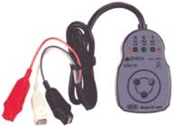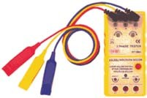

1. A single phase ring distributor *ABC* is fed at A. The loads at *B* and *C* are 40 A at 0·8 p.f. lagging and 60 A at 0·6 p.f. lagging respectively. Both power factors expressed are referred to the voltage at point A. The total impedance of sections *AB*, *BC* and *CA* are 2 + *j*1, 2 + *j*3 and 1 + *j*2 ohms respectively. Deter- mine the current in each section.

**[Current in *AB* = (39**·**54**  ***j* 25**·**05) amp ; *BC* = (7**·**54**  ***j* 1**·**05) amp ; *CA* = (28**·**46**  ***j* 46**·**95) amp.]**

1. A 3-phase ring distributor *ABCD* fed at A at 11 kV supplies balanced loads of 40 A at 0·8 p.f. lagging at *B*, 50 A at 0·707 p.f. lagging at C and 30 A at 0·8 p.f. lagging at D, the load currents being referred to the supply voltage at A.

The impedances per phase of the various sections are :

Section *AB* = (1 + *j* 2)  ; Section *BC* = (2 + *j* 3) 

Section *CD* = (1 + *j* 1)  ; Section *DA* = (3 + *j* 4) 

Calculate the currents in various sections and station bus-bar voltages at *B*, *C* and *D*.

**[Current in *AB* = (53**·**8**  ***j* 46) amp ; *BC* = (21**·**8**  ***j* 22) amp.**

***CD* = (****13**·**55 + *j* 13**·**35) amp ; *DA* = (****40**·**55**  ***j* 26**·**45) amp.**

***VB* = (6212**·**5**  ***j* 61**·**6) volts/phase ; *VC* = (6103**  ***j* 83) volts/phase**

***VD* = (6129**·**8**  ***j* 82**·**8) volts/phase]**

**[292 V, 2**·**6o]**

*A B*

*A*

Calculate the supply voltage *V* and phase angle between *V* and *V* .

TUTORIAL PROBLEMS

1. A single phase distributor *AB* has a total impedance of (0·1 + *j* 0·2) ohm. At the far end *B*, a current of 80 A at 0·8 p.f. lagging and at mid-point *C* a current of 100 A at 0·6 p.f. lagging are tapped. If the voltage of the far end is maintained at 200 V, determine :
   1. Supply end voltage *VA*
   2. Phase angle between *VA* and *VB*

The load power factors are w.r.t. the voltage at the far end. **[(*i*) 227**·**22 V (*ii*) 2o31****]**

1. A single-phase a.c. distributor *AB* is fed from end *A* and has a total impedance of (0·2 + *j* 03) ohm. At the far end, the voltage *VB* = 240 V and the current is 100 A at a p.f. of 0·8 lagging. At the mid-point *M*, a current of 100 A is tapped at a p.f. of 0·6 lagging with reference to the voltage *VM* at the mid-point.

Phase Sequence Indicator

# 3-Phase Unbalanced Loads

The 3-phase loads that have the same impedance and power factor in each phase are called balanced loads. The problems on balanced loads can be solved by considering one phase only ; the conditions in the other two phases being similar. However, we may come across a situation when loads are unbalanced *i.e.* each load phase has different impedance and/or power factor. In that case, current and power in each phase will be different. In practice, we may come across the following unbal- anced loads :

A.C. Distribution **367**



* + 1. Four-wire star-connected unbalanced load
    2. Unbalanced -connected load
    3. Unbalanced 3-wire, *Y*-connected load

The 3-phase, 4-wire system is widely used for distribution of electric power in commercial and industrial buildings. The single phase load is connected between any line and neutral wire while a 3-phase load is connected across the three lines. The 3-phase, 4-wire system invariably carries *un- balanced loads. In this chapter, we shall only discuss this type of unbalanced load.

# Four-Wire Star-Connected Unbalanced Loads

We can obtain this type of load in two ways. First, we may connect a 3-phase, 4-wire unbalanced load to a 3-phase, 4-wire supply as shown in Fig. 14.10. Note that star point *N* of the supply is connected to the load star point *N*. Secondly, we may connect single phase loads between any line and the neutral wire as shown in Fig.14.11. This will also result in a 3-phase, 4-wire **unbalanced load because it is rarely possible that single phase loads on all the three phases have the same magnitude and power factor. Since the load is unbalanced, the line currents will be different in magnitude and displaced from one another by unequal angles. The current in the neutral wire will be the phasor sum of the three line currents *i.e*.

Current in neutral wire, *IN* = *IR* + *IY* + *IB* ...*phasor sum*



The following points may be noted carefully :

* + 1. Since the neutral wire has negligible resistance, supply neutral *N* and load neutral *N* will be at the same potential. It means that voltage across each impedance is equal to the phase voltage of the supply. However, current in each phase (or line) will be different due to unequal impedances.
    2. The amount of current flowing in the neutral wire will depend upon the magnitudes of line currents and their phasor relations. In most circuits encountered in practice, the neutral current is equal to or smaller than one of the line currents. The exceptions are those circuits having severe unbalance.
* No doubt 3-phase loads (*e.g*. 3-phase motors) connected to this supply are balanced but when we add single phase loads (*e.g.* lights, fans etc.), the balance is lost. It is because it is rarely possible that single phase loads on all the three phases have the same magnitude and power factor.

** In actual practice, we never have an unbalanced 3-phase, 4-wire load. Most of the 3-phase loads (*e.g.* 3- phase motors) are 3-phase, 3-wire and are balanced loads. In fact, these are the single phase loads on the 3-phase, 4-wire supply which constitute unbalanced, 4-wire *Y*-connected load.

**368** Prin ciples of Power System



**Example 14.7.** *Non-reactive loads of 10 kW, 8 kW and 5 kW are connected between the neutral and the red, yellow and blue phases respectively of a 3-phase, 4-wire system. The line voltage is 400V. Calculate* (*i*) *the current in each line and* (*ii*) *the current in the neutral wire.*

**Solution.** This is a case of unbalanced load so that the line currents (and hence the phase cur- rents) in the three lines will be different. The current in the *neutral wire will be equal to the phasor sum of three line currents as shown in Fig. 14.12.



1. Phase voltage = 400/ 3 = 231 V

*I* = 10  103/231 = **43·3 A**

*R*

*I* = 8  103/231 = **34·6 A**

*Y*

*I* = 5  103/231 = **21·65 A**

*B*

1. The three lines currents are represented by the respective phasors in Fig. 14.13. Note that the three line currents are of different magnitude but displaced 120o from one another. The current in the neutral wire will be the phasor sum of the three line currents.

Resolving the three currents along *x*-axis and *y*-axis, we have,

*B*

Resultant horizontal component = *IY*

cos 30o  *I*

cos 30o

= 34·6  0·866  21·65  0·866 = 11·22 A

*B*

Resultant vertical component = *IR*

* *IY*

cos 60o  *I*

cos 60o

= 43·3  34·6  0·5  21·65  0·5 = 15·2 A As shown in Fig. 14.14, current in neutral wire is

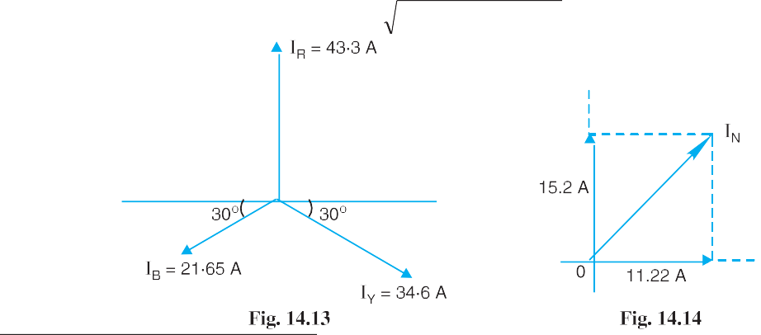

*IN* = a11 22f2  a15  2f2 = **18·9 A**

* Had the load been balanced (*i.e*. each phase having identical load), the current in the neutral wire would

have been zero.

A.C. Distribution **369**



**Example 14.8.** *A 3-phase, 4-wire system supplies power at 400 V and lighting at 230 V. If the lamps is use require 70, 84 and 33 amperes in each of the three lines, what should be the current in the neutral wire ? If a 3-phase motor is now started, taking 200 A from the lines at a p.f. of 0·2 lagging, what should be the total current in each line and the neutral wire ? Find also the total power supplied to the lamps and the motor.*

**Solution.** Fig. 14.15 shows the lamp load and motor load on 400 V/230 V, 3-phase, 4-wire sypply.

**Lamp load alone.** If there is lamp load alone, the line currents in phases *R*,*Y* and *B* are 70 *A*, 84 *A* and 33 *A* respectively. These currents will be 120o apart (assuming phase sequence *RYB*) as shown in Fig.14.16.



Resultant *H*-component = 84 cos 30o  33 cos 30o = 44·17 A Resultant V-component = 70  33 cos 60o  84 cos 60o = 11·5 A

 Neutral current, *IN* =

a44 17f2  a11 5f2

## Both lamp load and motor load

= **45·64 A**

When motor load is also connected along with lighting load, there will be no change in current in the neutral wire. It is because the motor load is balanced and hence no current will flow in the neutral wire due to this load.

 Neutral current, *IN* = **45·64 A** ...*same as before*

The current in each line is the phasor sum of the line currents due to lamp load and motor load.

Active component of motor current = 200  cos *m* = 200  0·2 = 40 A Reactive component of motor current = 200  sin *m* = 200  0·98 = 196 A

 *IR* =

bsum of active comp.g2  breactive comp.g2

=

*IY* =

b40  70g2  a196f2

b40  84g2  a196f2

b40  33g2  a196f2

= **224·8 A**

= **232 A**

## Power supplied

*IB* =

= **209·15 A**

Power supplied to lamps = 230 (70 + 84 + 33)  1 = **43010 W** ( cos *L* = 1)

**370** Prin ciples of Power System



Power supplied to motor =

=

*VLIL* cos *m*

 400  200  0·2 = **27712 W**

3

3

**Example 14.9.** *The three line leads of a 400/230 V, 3-phase, 4-wire supply are designated as R, Y and B respectively. The fourth wire or neutral wire is designated as N. The phase sequence is RYB. Compute the currents in the four wires when the following loads are connected to this supply :*

*From R to N* : *20 kW, unity power factor From Y to N* : *28·75 kVA, 0·866 lag From B to N* : *28·75 kVA, 0·866 lead*

*If the load from B to N is removed, what will be the value of currents in the four wires ?*

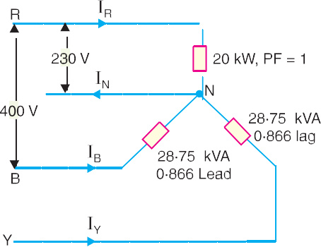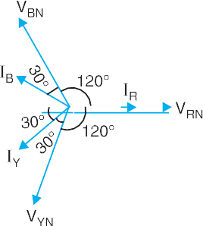

**Solution.** Fig. 14.17 shows the circuit diagram whereas Fig.14.18 shows its phasor diagram.

The current *I* is in phase with *V* , current *I* lags behind its phase voltage *V* by cos1 0*·*866 = 30o

*R RN*

*Y* 1

o *YN*

and the current *IB* leads its phase voltage *VBN* by cos 0*·*866 = 30 .

*I* = 20  103/230 = **89·96 A**

*R*

*I* = 28·75  103/230 = **125 A**

*Y*

*I* = 28·75  103/230 = **125 A**

*B*

The current in the neutral wire will be equal to the phasor sum of the three line currents *IR*, *IY* and *IB*. Referring to the phasor diagram in Fig.14.18 and resolving these currents along *x*-axis and *y*-axis, we have,

Resultant *X*-component = 86·96  125 cos 30o  125 cos 30o

= 86·96  108·25  108·25 =  129·54 A

Resultant *Y*-component = 0 + 125 sin 30o  125 sin 30o = 0

a129  54f2  a0f2

 Neutral current, *IN* =

= **129·54A**

**When load from *B* to *N* removed.** When the load from *B* to *N* is removed, the various line currents are :

*I* = **86·96A** in phase with *V* ; *I* = **125A** lagging *V* by 30o ; *I* = **0 A**

*R RN Y YN B*

The current in the neutral wire is equal to the phasor sum of these three line currents. Resolving the currents along *x*-axis and *y*-axis, we have,

Resultant *X*-component = 86·96  125 cos 30o = 86·96  108·25 =  21·29 A Resultant *Y*-component = 0  125 sin 30o = 0  125  0·5 =  62·5 A

b 21 29g2  b 62  5g2

 Neutral current, *IN* =

= **66·03 A**

A.C. Distribution **371**



**Example 14.10.** *A 3-phase, 4-wire distributor supplies a balanced voltage of 400/230 V to a load consisting of 30 A at p.f. 0·866 lagging for R-phase, 30 A at p.f. 0·866 leading for Y phase and 30 A at unity p.f. for B phase. The resistance of each line conductor is 0·2* *. The area of X-section of neutral is half of any line conductor. Calculate the supply end voltage for R phase. The phase sequence is RYB.*

**Solution.** The circuit diagram is shown in Fig. 14.19. Since neutral is half the cross-section, its resistance is 0·4 . Considering the load end and taking *VR* as the reference vector, the phase voltages can be written as :

*VR* = 230  0o volts ; *VY* = 230   120o volts ; *VB* = 230  120o volts

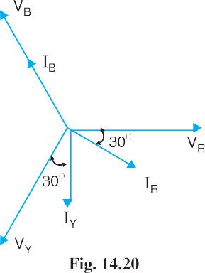

current *I* lags behind *V* by an angle cos1 0·866 = 30o. The current *I*

The vector diagram of the circuit is shown in Fig. 14.20. The line

*R R*

leads *VY* by 30 and the current *B*

o

*Y*

*I* is in phase with *V* . Referring to the

*B*

vector diagram of Fig.14.20, the line currents can be expressed as :

*IR* = 30   30 amperes *IY* = 30   90 amperes *IB* = 30  120 amperes

o

o

o

Current in neutral wire, *IN* = *IR*  *IY*  *IB*

= 30  30o + 30   90o + 30  120o

= 30 (0·866  *j* 0·5)  30 (*j*) + 30 ( 0·5 + *j* 0·866)

= 10·98  *j* 19·02 Let the supply voltage of phase *R* to neutral be *ER* . Then,

*ER* = *VR* + Drop in *R* phase + Drop in neutral

= (230 + *j* 0) + 0·2  30   30o + (10·98  *j* 19·02)  0·4

= 230 + 6 (0·866  *j* 0·5) + 0·4 (10·98 *j* 19·02)

= 239·588  *j* 10·608

= **239·8**  **2·54o volts**

**372** Prin ciples of Power System



**Example 14.11.** *In a 3-phase, 4-wire, 400/230 V system, a lamp of 100 watts is connected to one phase and neutral and a lamp of 150 watts is connected to the second phase and neutral. If the neutral wire is disconnected accidentally, what will be the voltage across each lamp* ?

**Solution.** Fig. 14.21 (*i*) shows the lamp connections. The lamp *L*1 of 100 watts is connected between phase *R* and neutral whereas lamp *L*2 of 150 watts is connected between phase *Y* and the neutral.

Resistance of lamp *L*1, *R*1 = Resistance of lamp *L*2, *R*2 =

a230f2

100

a230f2

150

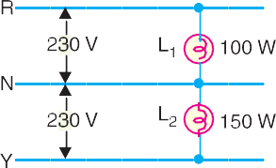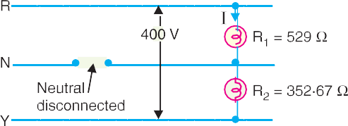

= 529 

= 352·67 

When the neutral wire is disconnected as shown in Fig. 14.21 (*ii*), the two lamps are connected in series and the p.d. across the combination becomes equal to the line voltage *EL* (= 400 V).

*EL*

Current through lamps, *I* = *R*1  *R*2

400

529  352  67

= = 0·454 A

Voltage across lamp *L*1 = *I R*1 = 0·454  529 = **240 V**

Voltage across lamp *L*2 = *I R*2 = 0·454  352·67 = **160 V**

***Comments.*** The voltage across 100-watt lamp is increased to 240 V whereas that across 150- watt is decreased to 160 V. Therefore, 100-watt lamp becomes brighter and 150-watt lamp becomes dim. It may be noted here that if 100-watt lamp happens to be rated at 230 V, it may burn out due to 240 V coming across it.

TUTORIAL PROBLEMS

1. Non-reactive loads of 10 kW, 6kW and 4 kW are connected between the neutral and red, yellow and blue phases respectively of a 3-phase, 4-wire 400/230V supply. Find the current in each line and in the neutral wire. **[IR = 43**·**3 A; IY = 26 A; IB = 17**·**3 A; IN = 22**·**9 A]**
2. A factory has the following loads with a power factor of 0·9 lagging in each case. Red phase 40 A, yellow phase 50 A and blue phase 60 A. If the supply is 400V, 3-phase, 4-wire, calculate the current in the neutral wire and the total power. **[17**·**3A, 31**·**2 kW]**
3. In a 3-phase, 4-wire system, two phases have currents of 10A and 6A at lagging power factors of 0·8 and 0·6 respectively, while the third phase is open-circuited. Calculate the current in the neutral wire. **[7A]**
4. A 3-phase, 4-wire system supplies a lighting load of 40A, 30A and 20A respectively in the three phases. If the line voltage is 400 V, determine the current in the neutral wire. **[17**·**32A]**

# Ground Detectors

Ground detectors are the devices that are used to detect the ground fault for ungrounded a.c. systems.

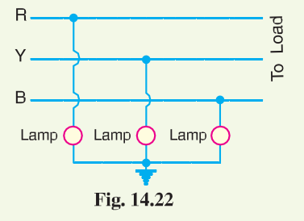

When a ground fault occurs on such a system, immediate steps should be taken to clear it. If this is not done and a second ground fault happens, a short circuit occurs.

Fig.14.22 shows how lamps are connected to an un- grounded 3-phase system for the detection of ground fault. If ground fault occurs on any wire, the lamp connected to that wire will be dim and the lamps connected to healthy (un- grounded) wire will become brighter.

A.C. Distribution **373**

# SELF - TEST

* + 1. **Fill in the blanks by inserting appropriate words/figures.**
       1. The most common system for secondary distribution is 400/..... V, 3-phase, wire system.
       2. In a 3-phase, 4-wire a.c. system, if the loads are balanced, then current in the neutral wire is .........
       3. Distribution transformer links the ............ and systems.
       4. The 3-phase, 3-wire a.c. system of distribution is used for loads.
       5. For combined power and lighting load, system is used.
    2. **Pick up the correct words/figures from brackets and fill in the blanks.**
       1. 3-phase, 4-wire a.c. system of distribution is used for .............. load. (*balanced, unbalanced*)
       2. In a balanced 3-phase, 4-wire a.c. system, the phase sequence is *RY B*. If the voltage of *R* phase = 230  0o volts, then for *B* phase it will be .............. (*230*   *120o volts, 230*  *120o volts*)
       3. In a.c. system, additions and subtractions of currents are done ..............

(*vectorially, arithmetically*)

* + - 1. The area of X-section of neutral is generally that of any line conductor. (*the same, half*)
      2. For purely domestic loads, a.c. system is employed for distribution.

(*single phase 2-wire, 3-phase 3-wire*)

ANSWERS TO SELF-TEST

1. (*i*) 230, 4 (*ii*) zero (*iii*) primary, secondary (*iv*) balanced (*v*) 3-phase 4-wire.
2. (*i*) unbalanced (*ii*) 230 120o (*iii*) vectorially (*iv*) half (*v*) single phase 2-wire.

# CHAPTER REVIEW TOPICS

1. How does a.c. distribution differ from d.c. distribution ?
2. What is the importance of load power factors in a.c. distribution ?
3. Describe briefly how will you solve a.c. distribution problems ?
4. Write short notes on the following :
   1. Difference between d.c. and a.c. distribution
   2. Systems of a.c. distribution

DISCUSSION QUESTIONS

1. What are the undesirable effects of too much voltage variation on a distribution circuit ?
2. What are the effects of diversity factor on the maximum load of a distribution transformer ?
3. Where does the greatest current density occur in a distribution feeder ?
4. What is the controlling factor in determining the size of a distributor ?
5. In which situation is secondary distribution eliminated ?



GO To FIRST